Engineering Computing Lab II
EGC – 250

Final Project

Rafiul Karim Rasel

Course Professor: Faramarz Vaziri, Ph.D.

Due: December 14, 2011

Submitted: December 14, 2011

Table of Contents
Introduction: 5
Objective: 5
MATLAB Functions: 5
Procedure: 6
Simulation 15
Extras 17
Conclusion 17
Works Cited 18
Appendix 19
Code 19

Introduction:
To understand math and geometry visualization is very important. For humans plotting two-dimensional graph is very easy. In reality what ever our eyes see is three-dimensional and it is very difficult to visualize a three-dimensional plot from the equation. Now in the era of computing there are hundreds of software capable of plotting complicated functions in two or three-dimensional space. MATLAB is a very strong tool to visualizing and plotting complicated graph.

Objective:
The objective of this project is to make a graphing calculator using graphical user interface of MATLAB, which will graph and simulate two-dimensional plot. It should also perform some tasks defined by the user like finding the minimum and maximum, showing the x and y ordinate of an user defined position in the graph and others. The design of this graphing calculator is open ended, so the designing of this calculator is fully up to the student and if they want they can add more functions to the calculator.

MATLAB Functions:
For this project i used more than ten predefined MATLAB functions. I will explain all the functions that I used in an alphanumerical order. In this programming for plotting I used x as horizontal, y as vertical and and z as the third dimension of the graph.
- clc, cla – these functions clear screen and and graph.
- contour3(x,y,z) – the countour3 function of MATLAB works same as mesh function, the difference is rather creating a surface plot it creates a contour plot from the information .
- diff(vector) – the diff function of MATLAB finds the numerical differentiation of the given vectors.
- ezplot('f(x,y)') – the ezplot function of MATLAB take an implicit argument of x and y, and plot them and accordingly in vertical and horizontal position.
- get(handle, 'property') – this function get the defined property from the object.
- gtext – this function enables the user to use the cursor to insert a string in graph
- Isosurface(x,y,z,v,0) – isosurface function of MATLAB take four arguments x, y, z and v where v = f(x, y, z) and v = 0 then create a surface plot from the implicit equation of f(x,y,z) = 0
- Mesh(x,y,z) – the mesh function of MATLAB take a n x n matrix of x, y and z then create a surface plot out of it.
- num2str(double value) – this function convert the double to a string.
- plot(x, y) – the plot fucntion of MATLAB take two variable (x and y coordinate points) and plot them.
- Polar(tht, r) – the polar function of MATLAB create polar plot of r and theta.
- set(handle, 'Property', 'property value') – set command works with objects to set properties of the object.
- str2num('String') – this function convert the string to a double value.
- Strcat('String1', 'String2') – this function concatenate two string.
- text(x, y, z, 'String') – this function insert the user defined string in a predefined location

Procedure:
The guide command of MATLAB in command window open the graphical user interface for the MATLAB. From there under ‘the creates new GUI tab’, Blank GUI has to be selected. It will open the graphical user interface to design software and program with user interface. After saving the file it will save it as a .fig file. Now the .fig file is editable file in MATLAB. In editing mode of .fig file, in the left side there is a tool bar to select push-button, graphing window, text-box, edit-box and others to design. The first thing is to create a good graphical user interface to experience a better looks. After that GUI for the calculator of the project has been designed and simulated. The GUI of my project looks like

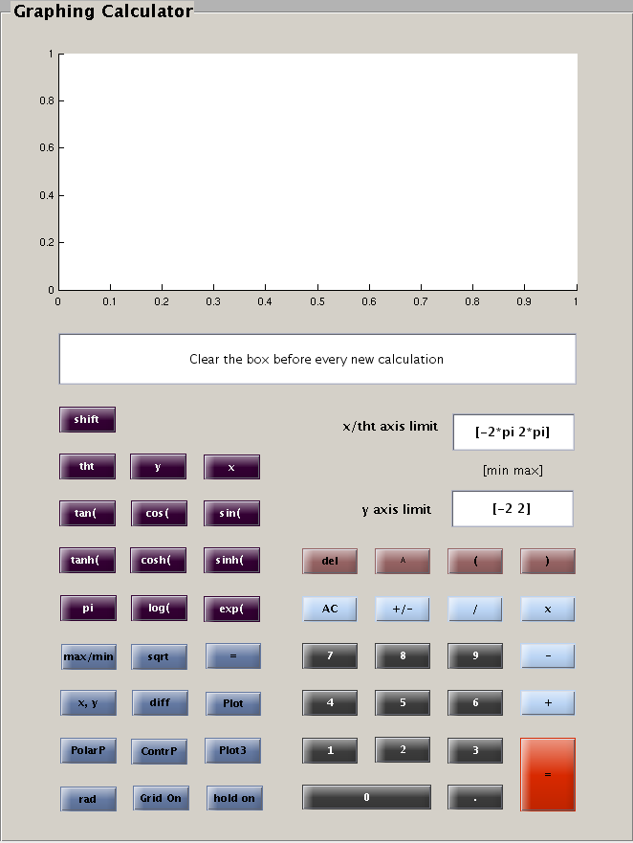

Fig: GUI of the Calculator

After running the GUI it will generate a .m file related to the figure. It will also generate function for all the object that has been used to create the GUI. While crating the GUI the tag for all the objects has been changed according to the name of the object. It will help later to find the appropriate function to manipulate the object.
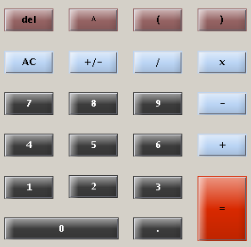
Fig: A fragment of the calculator

for this part of the GUI all the buttons uses same programming accept for the '=', 'AC', 'del' and the '+/-' buttons. And the code for the buttons is

function Tag_Callback(hObject, eventdata, handles)
textString = get(handles.Tag2, 'String');
textString = strcat(textString, get(handles.Tag, ...
'String'));
set(handles.Tag2, 'String', textString);

here Tag is the name of the functions for the buttons and Tag2 is the name of the function of the edit box. The first line get the function as a string form the edit box. The second line get the font from the buttons and concatenate with the previous string. The third line set the new string in the edit box.

Code for the 'del' button

function del_Callback(hObject, eventdata, handles)
textString = get(handles.edit2, 'String');
len = length(textString);
textString(len) = [];
set(handles.edit2, 'String', textString);
this function delete the last character from the edit box. The fist line of the code does the same this as expected. The third line delete the last character and forth line set the character in the edit box.

function clear_Callback(hObject, eventdata, handles)
set(handles.edit2, 'String', '');
title('')
cla;

this function of the button AC clear everything.

Code for the '+/-' button

function plus_min_Callback(hObject, eventdata, handles)
textString = get(handles.edit2, 'String');
if textString(1) ~= '-'
textString = strcat('-', textString);
else
textString(1) = [];
end
set(handles.edit2, 'String', textString);

this function of '+/-' button allow the user to add + or – sign in front of the string of the edit box. The if else statement decide whether to add a plus or minus sign to the string. The last line set the string to edit box.

Code for the '+/-' button

function evalute_Callback(hObject, eventdata, handles)
textString = get(handles.edit2, 'String');
if length(textString) ~= 0
textString = eval(textString);
end
set(handles.edit2, 'String', textString);

this function of '=' button take the string form the edit box and evaluate it numerically and set the answer to the edit box.
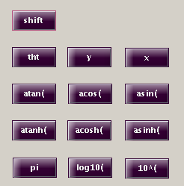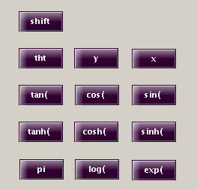
Fig: Snapshot of some buttons of the calculator
This buttons of the calculator used for the default functions. The user can use these default function or can manually input the function in the edit box. This buttons of this GUI uses the same programming code as explained earlier. And the code is

function Tag_Callback(hObject, eventdata, handles)
textString = get(handles.Tag2, 'String');
textString = strcat(textString, get(handles.Tag, 'String'));
set(handles.Tag2, 'String', textString);

the code for the shift button is different it uses to toggle the button from one state to another as shown in previous figures. When shift has been pressed it change all sin functions to it inverse functions. The code for this button is

function pushbutton39_Callback(hObject, eventdata, handles)
global toggle;
if toggle ~ 0
toggle = 1-toggle;
set(handles.sin, 'string', 'sin('); set(handles.cos, 'string', 'cos(');
set(handles.tan, 'string', 'tan('); set(handles.sinh, 'string', 'sinh(');
set(handles.cosh, 'string', 'cosh('); set(handles.tanh, 'string', 'tanh(');
set(handles.log, 'string', 'log('); set(handles.exp, 'string', 'exp(');
else
toggle = 1;
set(handles.sin, 'string', 'asin('); set(handles.cos, 'string', 'acos(');
set(handles.tan, 'string', 'atan('); set(handles.sinh, 'string', 'asinh(');
set(handles.cosh, 'string', 'acosh('); set(handles.tanh, 'string', 'atanh(');
set(handles.log, 'string', 'log10('); set(handles.exp, 'string', '10^(');
end

this part of the code use to toggle the button. If shift has been pressed which means it has been toggled it will set all the button with different functions. If shift button has been pressed again it will restore the previous functions.
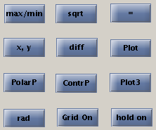
Fig: Function Buttons of the calculator

This part of the calculator has all the main functions like plotting, differentiating, finding max/min, showing the x and y coordinate and others. All of the button has different type of code.

The plot button plots two-dimensional graph from both explicit and implicit equation of x and y, where x is the horizontal and y is the vertical coordinate values. The code for this button is

function plot_Callback(hObject, eventdata, handles)
a=0;
textString = deblank(get(handles.edit2, 'String'));
range1 = str2num(get(handles.edit3, 'String'));
range2 = str2num(get(handles.edit5, 'String'));
for i = 1:length(textString)
if textString(i) == '='
a = 1;
end
end
set(handles.edit2, 'String', textString);
y = range1(1):pi/30:range1(2);
for i = length(textString):-1:1
if (textString(i) == '^' || textString(i) == '/' || textString(i) == '*')
textString = [textString(1:i-1) '.' textString(i:length(textString))];
end
end
if a == 1
ha = ezplot(textString);
set(ha, 'linewidth', 2, 'linestyle', '--', 'color', 'k');
axis([range1(1) range1(2) range2(1) range2(2)]);
else
x = [];
for i = y
x = [x i];
plot(x, eval(textString), '--', 'linewidth', 2, 'color', 'r' );
axis([range1(1) range1(2) range2(1) range2(2)]);
pause(.001);
end
end
handle = title(['"' get(handles.edit2, 'String') '"']);
set(handle, 'fontsize', 20, 'color', [.2 .5 .3]);
xlabel('x axis'); ylabel('y axis');

this function get the x and y coordinate range from the edit box as vector and use them to evaluate the function and plot it. In MATLAB the dot (.) sign is very important for matrix and vector multiplication, division and for the power. The ‘.’ Sign has to be inserted before every matrix multiplication, division or when finding the power. This code has a parsing section for dot sign which means user does not have to provide the dot sign in the function this code will insert the dot sign by itself. The if-else statement is for deciding if the function is implicit or explicit. If the function is implicit it will create an implicit plot of the function using ezplot. If the function is explicit it will plot using the plot command.

Now the code for the plot3 button is

function plot3_Callback(hObject, eventdata, handles)
a = 0;
textString = get(handles.edit2, 'String');
textString(length(textString)+1) = ' ';
set(handles.edit2, 'String', textString);
for i = length(textString):-1:1
if (textString(i) == '^' || textString(i) == '/' || textString(i) == '*')
textString = [textString(1:i-1) '.' textString(i:length(textString))];
end
end
range = str2num(get(handles.edit3, 'String'));
x = range(1):pi/30:range(2);
range = str2num(get(handles.edit5, 'String'));
y = range(1):pi/30:range(2);
for i = length(textString):-1:1
if textString(i) == '='
a = 1;
textString = textString(1:i-1);
end
end
if a == 1
cla
range = str2num(get(handles.edit3, 'String'));
x = range(1):pi/10:range(2);
[x, y, z] = ndgrid(x);
v = eval(textString);
p = patch(isosurface(x,y,z,v,0)); rotate3d on;
set(p,'FaceColor','b', 'EdgeColor', 'g', 'FaceAlpha',0.3);
grid on;
camlight
view(-27,46);
lighting gouraud
else
[x,y] = meshgrid(x,y);
z = eval(textString);
rotate3d on;
mesh(x,y,z);
end
handle = title(['"' get(handles.edit2, 'String') '"']);
set(handle, 'fontsize', 20, 'color', [.2 .5 .3]);
xlabel('x axis'); ylabel('y axis'); zlabel('z axis');

this code do the same thing as the code for plot button do. It inserts the dot sign in every calculation. This function creates three-dimensional plot for explicit and implicit function. The implicit function has to be a form like f(x, y, z) = 0 to work. This function has if-else statement to choose the right plot for right type of function. If the function is explicit which means it does not has any ‘=’ sign then it uses meshgrid command to generate a same size of matrix for x and y. then using mesh command the surface plot has been ploted. The rotate3d command enables the 3d roatation. For the implicit plot using ndgrid the matrix of x, y and z has been created. The function f(x,y,z)=0 has been evaluated and ploted using isosurface and patch command. The rest of the command is for making the plot nicer.
The code for the contour plot button

function contourplot_Callback(hObject, eventdata, handles)
textString = get(handles.edit2, 'String');
for i = length(textString):-1:1
if (textString(i) == '^' || textString(i) == '/' || textString(i) == '*')
textString = [textString(1:i-1) '.' textString(i:length(textString))];
end
end
range = str2num(get(handles.edit3, 'String'));
x = range(1):pi/30:range(2);
range = str2num(get(handles.edit5, 'String'));
y = range(1):pi/30:range(2);
[x,y] = meshgrid(x,y);
z = eval(textString);
contour3(x,y,z);
handle = title(['"' get(handles.edit2, 'String') '"']);
set(handle, 'fontsize', 20, 'color', [.2 .5 .3]);
xlabel('x axis'); ylabel('y axis'); zlabel('z axis');

the code for this function is almost same as the code for plot3 button, except for it does not do any implicit plotting. It uses contour3 command instead of mesh to generate contour plot of the explicit function.

The code for the polarP button

function polarplot_Callback(hObject, eventdata, handles)
textString = get(handles.edit2, 'String');
for i = length(textString):-1:1
if (textString(i) == '^' || textString(i) == '/' || textString(i) == '*')
textString = [textString(1:i-1) '.' textString(i:length(textString))];
end
end
range = str2num(get(handles.edit3, 'String'));
tht = range(1):pi/30:range(2);
r = eval(textString);
if length(r) == 1
r = r*ones(1, length(tht));
end
polar(tht,r);
title('Polar plot');

this code take the function in terms of tht and then plot the function as a polar plot using polar command. It also has a section that parse the dot sign in the code.

The code for diff button..

function diffplot_Callback(hObject, eventdata, handles)
textString = get(handles.edit2, 'String');
for i = length(textString):-1:1
if (textString(i) == '^' || textString(i) == '/' || textString(i) == '*')
textString = [textString(1:i-1) '.' textString(i:length(textString))];
end
end
range1 = str2num(get(handles.edit3, 'String'));
range2 = str2num(get(handles.edit5, 'String'));
x = range1(1):pi/30:range1(2);
y = diff(eval(textString)).*10;
x(length(x)) = [];
% x = [];
for i = 1:length(y)
% x = [x i];
plot(x(1:i), y(1:i), '--', 'linewidth', 2, 'color', 'k' );
axis([range1(1) range1(2) range2(1) range2(2)]);
pause(.001);
end
handle = title(['"' ' diff(' get(handles.edit2, 'String') ')"']);
set(handle, 'fontsize', 20, 'color', [.2 .5 .3]);
xlabel('x axis'); ylabel('y axis');

this function takes the string from the edit box then evaluate in the range of x. then using diff command it find the numerical differentiation of evaluated vector. It has to be normalized to get the correct value. The length of the differentiated vector is one minus the length of the x vector. So it deleted the last component of x and using plot command it plots the differentiated function. A for loop has been used with the plot command to add animation in the graph.

The code for the x,y button

function showXY_Callback(hObject, eventdata, handles)
han = gtext(' ');
a = get(han, 'Position');
han1 = text(a(1), a(2), ['';'x = ', num2str(a(1)), '\newliney = ',...
num2str(a(2))])
set(han1, 'Fontsize', 10, 'FontWeight', 'bold', 'Color', 'b',...
'BackgroundColor', [1 1 1] );

this function uses gtext command to find the coordinate of the difined point in the graph. Using get with the property of position the position of the point has been acquired. Then using text command it shows the x and y coordinated point on the graph.

The code for the set max and min button

function set_maxmin_Callback(hObject, eventdata, handles)
a=0; b=0;
textString = get(handles.edit2, 'String');
for i = length(textString):-1:1
if (textString(i) == '^' || textString(i) == '/' || textString(i) == '*')
textString = [textString(1:i-1) '.' textString(i:length(textString))];
end
if (textString(i) == '=')
textString = textString(i+1:length(textString));
end
end
if (length(textString) ~= length(deblank(textString)))
range1 = str2num(get(handles.edit3, 'String'));
range2 = str2num(get(handles.edit5, 'String'));
x = range1(1):pi/80:range1(2);
y = range1(1):pi/80:range1(2);
z = eval(textString);
for i = find(z == max(z))
text(x(i), y(i), max(z), 'Maximum');
end
for i = find(z == min(z))
text(x(i), y(i), min(z), 'Minimum');
end
else
range = str2num(get(handles.edit3, 'String'));
x = range(1):pi/80:range(2);
y = eval(textString);
for i = find(y == max(y))
text(x(i), max(y),'\downarrow Maximum',...
'HorizontalAlignment','left');
end
for i = find(y == min(y))
text(x(i), min(y),'\uparrow Minimum',...
'HorizontalAlignment','left');
end
end

This function finds the maximum and minimum point on two or three-dimensional graph. It only works for explicit equations. Using max command it finds the maximum value and then using find(y == max(y)) command it find the location of all maximum in the vector. Using those two information and text command the maximum has been added in the plot. For finding minimum the algorithm is exactly same.

The code for the ‘hold on’ and ‘grid on’ button are almost same they uses toggle to
Toggle between ‘hold on/off’ and ‘grid on/off’ and perform the tasks. This calculator has Three edit box, one for writing functions and other two for the limits of x, y and tht. It has one graphing window in it to plot functions.

Simulation
After successfully coding all the function has been simulated using the GUI, and it works amazingly! The snapshot of the working GUI is attached here
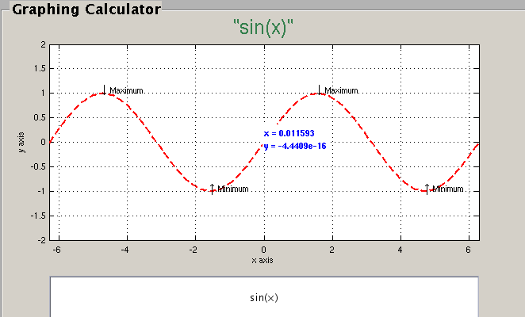
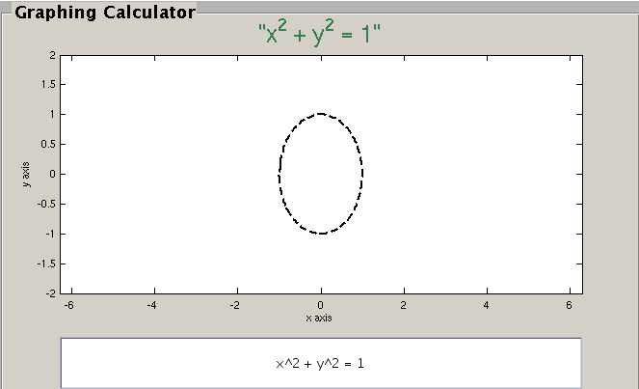
Fig: Plot of explicit and implicit function

The snapshot of left sideshows the plot of explicit function and the snapshot of the right side show the plot of and implicit function. Thus showing the capability of plotting both explicit and implicit functions. The right side of the plot also showing the ability of plotting max and min in the graph; and also showing x and y value of a point in the graph.

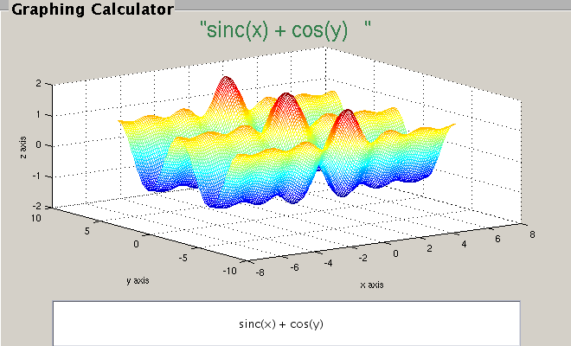

Fig: 3D plot of explicit function

This is the snap shot of a three D explicit function. We can see that this is a function of x and y and it is sinc function is the direction of x and cosine in the direction of y which also verify equation. Thus the three D plotting of this calculator is about correct.

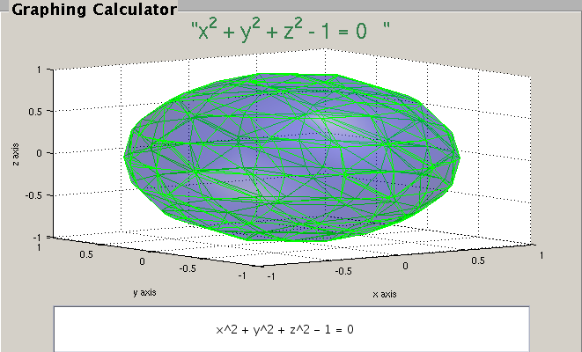
Fig: 3D plot of an implicit function

This is the 3D plot of an implicit function which shows the capability of the calculator to plot implicit 3D function of x, y and z.

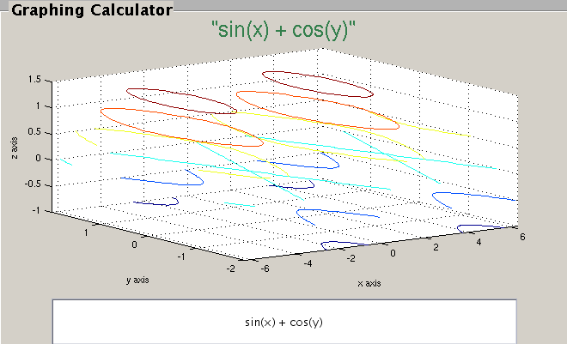
Fig: Contour Plot of 3D function

This is a contour plot of three D function generated by the calculator.

Extras
In this code many thing has been added which was not required. This function is fully capable of plotting both explicit and implicit function. The implicit function for 3D plot has to be a function like f(x,y,z) = 0 to work and the two dimensional implicit plot works for any type of implicit notation. Implicit plot of two and three-dimensional function is an extra work. The three dimensional and contour plots were not necessary but this calculator can plot both of these types of plots, which are also an extra work. This calculator can find the differentiation of a vector numerically and plot that. It can also plot a polar function, which was not required. Using the shift button of the calculator one person can navigate between two different default functions. Which is also an extra addition.

Conclusion
Programming this GUI was fun and challenging at the same type. Even though I do not need that much extra credit I created all the functions just for fun and learning. While coding for my GUI I learned about many default functions and gained some programming skill for graphical user interface programming. At the beginning of the project I was having some difficulties to incorporate the object and functions with the code, I read the book and search online for help and I found out how to code and started coding after that I did not has that much of problem coding any of the above functions.

Works Cited

Designing GUI interfaces in MATLAB. http://www.intelligent-systems.info/classes/
ee509/gui.htm. December 2, 2011

Mathworks, Product Documentation. http://www.mathworks.com/help/techdoc/
ref/. December 5, 2011

Appendix

Code

function varargout = Calculator(varargin)
global toggle;
% CALCULATOR MATLAB code for Calculator.fig
% CALCULATOR, by itself, creates a new CALCULATOR or raises the existing
% singleton*.
%
% H = CALCULATOR returns the handle to a new CALCULATOR or the handle to
% the existing singleton*.
%
% CALCULATOR('CALLBACK',hObject,eventData,handles,...) calls the local
% function named CALLBACK in CALCULATOR.M with the given input arguments.
%
% CALCULATOR('Property','Value',...) creates a new CALCULATOR or raises the
% existing singleton*. Starting from the left, property value pairs are
% applied to the GUI before Calculator_OpeningFcn gets called. An
% unrecognized property name or invalid value makes property application
% stop. All inputs are passed to Calculator_OpeningFcn via varargin.
%
% *See GUI Options on GUIDE's Tools menu. Choose "GUI allows only one
% instance to run (singleton)".
%
% See also: GUIDE, GUIDATA, GUIHANDLES

% Edit the above text to modify the response to help Calculator

% Last Modified by GUIDE v2.5 07-Dec-2011 23:36:27

% Begin initialization code - DO NOT EDIT
gui_Singleton = 1;
gui_State = struct('gui_Name', mfilename, ...
'gui_Singleton', gui_Singleton, ...
'gui_OpeningFcn', @Calculator_OpeningFcn, ...
'gui_OutputFcn', @Calculator_OutputFcn, ...
'gui_LayoutFcn', [] , ...
'gui_Callback', []);
if nargin && ischar(varargin{1})
gui_State.gui_Callback = str2func(varargin{1});
end

if nargout
[varargout{1:nargout}] = gui_mainfcn(gui_State, varargin{:});
else
gui_mainfcn(gui_State, varargin{:});
end
% End initialization code - DO NOT EDIT

function Calculator_OpeningFcn(hObject, eventdata, handles, varargin)
% Choose default command line output for Calculator
handles.output = hObject;
set(hObject, 'toolbar', 'figure');
% Update handles structure
guidata(hObject, handles);

% --- Outputs from this function are returned to the command line.
function varargout = Calculator_OutputFcn(hObject, eventdata, handles)
varargout{1} = handles.output;

% --- Executes on button press in del.
function del_Callback(hObject, eventdata, handles)
textString = get(handles.edit2, 'String');
len = length(textString);
textString(len) = [];
set(handles.edit2, 'String', textString);

% --- Executes on button press in power.
function power_Callback(hObject, eventdata, handles)
textString = get(handles.edit2, 'String');
textString = strcat(textString, get(handles.power, 'String'));
set(handles.edit2, 'String', textString);

% --- Executes on button press in brace_1.
function brace_1_Callback(hObject, eventdata, handles)

textString = get(handles.edit2, 'String');
textString = strcat(textString, get(handles.brace_1, 'String'));
set(handles.edit2, 'String', textString);

% --- Executes on button press in brace_2.
function brace_2_Callback(hObject, eventdata, handles)
textString = get(handles.edit2, 'String');
textString = strcat(textString, get(handles.brace_2, 'String'));
set(handles.edit2, 'String', textString);

% --- Executes on button press in clear.
function clear_Callback(hObject, eventdata, handles)
set(handles.edit2, 'String', '');
title('')
cla;

% --- Executes on button press in plus_min.
function plus_min_Callback(hObject, eventdata, handles)
textString = get(handles.edit2, 'String');
if textString(1) ~= '-'
textString = strcat('-', textString);
else
textString(1) = [];
end

set(handles.edit2, 'String', textString);

% --- Executes on button press in divid.
function divid_Callback(hObject, eventdata, handles)
textString = get(handles.edit2, 'String');
textString = strcat(textString, get(handles.divid, 'String'));
set(handles.edit2, 'String', textString);

% --- Executes on button press in multiply.
function multiply_Callback(hObject, eventdata, handles)
textString = get(handles.edit2, 'String');
textString = strcat(textString, '*');
set(handles.edit2, 'String', textString);

% --- Executes on button press in seven.
function seven_Callback(hObject, eventdata, handles)
textString = get(handles.edit2, 'String');
textString = strcat(textString, get(handles.seven, 'String'));
set(handles.edit2, 'String', textString);

% --- Executes on button press in eight.
function eight_Callback(hObject, eventdata, handles)
textString = get(handles.edit2, 'String');
textString = strcat(textString, get(handles.eight, 'String'));
set(handles.edit2, 'String', textString);

% --- Executes on button press in nine.
function nine_Callback(hObject, eventdata, handles)
textString = get(handles.edit2, 'String');
textString = strcat(textString, get(handles.nine, 'String'));
set(handles.edit2, 'String', textString);

% --- Executes on button press in minus.
function minus_Callback(hObject, eventdata, handles)
textString = get(handles.edit2, 'String');
textString = strcat(textString, get(handles.minus, 'String'));
set(handles.edit2, 'String', textString);

% --- Executes on button press in four.
function four_Callback(hObject, eventdata, handles)
textString = get(handles.edit2, 'String');
textString = strcat(textString, get(handles.four, 'String'));
set(handles.edit2, 'String', textString);

% --- Executes on button press in five.
function five_Callback(hObject, eventdata, handles)
textString = get(handles.edit2, 'String');
textString = strcat(textString, get(handles.five, 'String'));
set(handles.edit2, 'String', textString);

% --- Executes on button press in six.
function six_Callback(hObject, eventdata, handles)
textString = get(handles.edit2, 'String');
textString = strcat(textString, get(handles.six, 'String'));
set(handles.edit2, 'String', textString);

% --- Executes on button press in plus.
function plus_Callback(hObject, eventdata, handles)
textString = get(handles.edit2, 'String');
textString = strcat(textString, get(handles.plus, 'String'));
set(handles.edit2, 'String', textString);

% --- Executes on button press in one.
function one_Callback(hObject, eventdata, handles)
textString = get(handles.edit2, 'String');
textString = strcat(textString, get(handles.one, 'String'));
set(handles.edit2, 'String', textString);

% --- Executes on button press in two.
function two_Callback(hObject, eventdata, handles)
textString = get(handles.edit2, 'String');
textString = strcat(textString, get(handles.two, 'String'));
set(handles.edit2, 'String', textString);

% --- Executes on button press in three.
function three_Callback(hObject, eventdata, handles)
textString = get(handles.edit2, 'String');
textString = strcat(textString, get(handles.three, 'String'));
set(handles.edit2, 'String', textString);

% --- Executes on button press in evalute.
function evalute_Callback(hObject, eventdata, handles)
textString = get(handles.edit2, 'String');
if length(textString) ~= 0
textString = eval(textString);
end
set(handles.edit2, 'String', textString);

% --- Executes on button press in zero.
function zero_Callback(hObject, eventdata, handles)
textString = get(handles.edit2, 'String');
textString = strcat(textString, get(handles.zero, 'String'));
set(handles.edit2, 'String', textString);

% --- Executes on button press in dec.
function dec_Callback(hObject, eventdata, handles)
textString = get(handles.edit2, 'String');
textString = strcat(textString, get(handles.dec, 'String'));
set(handles.edit2, 'String', textString);

% --- Executes on button press in x.
function x_Callback(hObject, eventdata, handles)
textString = get(handles.edit2, 'String');
textString = strcat(textString, get(handles.x, 'String'));
set(handles.edit2, 'String', textString);

% --- Executes on button press in y.
function y_Callback(hObject, eventdata, handles)
textString = get(handles.edit2, 'String');
textString = strcat(textString, get(handles.y, 'String'));
set(handles.edit2, 'String', textString);

% --- Executes on button press in equalsign.
function equalsign_Callback(hObject, eventdata, handles)
textString = get(handles.edit2, 'String');
textString = strcat(textString, get(handles.equalsign, 'String'));
set(handles.edit2, 'String', textString);

% --- Executes on button press in plot.
function plot_Callback(hObject, eventdata, handles)
a=0;
textString = deblank(get(handles.edit2, 'String'));
range1 = str2num(get(handles.edit3, 'String'));
range2 = str2num(get(handles.edit5, 'String'));
for i = 1:length(textString)
if textString(i) == '='
a = 1;
end
end
set(handles.edit2, 'String', textString);
y = range1(1):pi/30:range1(2);
for i = length(textString):-1:1
if (textString(i) == '^' || textString(i) == '/' || textString(i) == '*')
textString = [textString(1:i-1) '.' textString(i:length(textString))];
end
end
if a == 1
ha = ezplot(textString);
set(ha, 'linewidth', 2, 'linestyle', '--', 'color', 'k');
axis([range1(1) range1(2) range2(1) range2(2)]);
else
x = [];
for i = y
x = [x i];
plot(x, eval(textString), '--', 'linewidth', 2, 'color', 'r' );
axis([range1(1) range1(2) range2(1) range2(2)]);
pause(.001);
end
end
handle = title(['"' get(handles.edit2, 'String') '"']);
set(handle, 'fontsize', 20, 'color', [.2 .5 .3]);
xlabel('x axis'); ylabel('y axis');

% --- Executes on button press in cos.
function cos_Callback(hObject, eventdata, handles)
textString = get(handles.edit2, 'String');
textString = strcat(textString, get(handles.cos, 'String'));
set(handles.edit2, 'String', textString);

% --- Executes on button press in sin.
function sin_Callback(hObject, eventdata, handles)
textString = get(handles.edit2, 'String');
textString = strcat(textString, get(handles.sin, 'String'));
set(handles.edit2, 'String', textString);

% --- Executes on button press in pushbutton32.
function pushbutton32_Callback(hObject, eventdata, handles)
textString = get(handles.edit2, 'String');
textString = strcat(textString, 'pi');
set(handles.edit2, 'String', textString);

% --- Executes on button press in grid.
function grid_Callback(hObject, eventdata, handles)
global toggle;
if toggle ~ 0
toggle = 1-toggle;
grid off;
set(handles.grid, 'string', 'Grid on');
else
toggle = 1;
grid on;
set(handles.grid, 'string', 'Grid off');
end

% --- Executes on button press in showXY.
function showXY_Callback(hObject, eventdata, handles)
han = gtext(' ');
a = get(han, 'Position');
han1 = text(a(1), a(2), ['';'x = ', num2str(a(1)), '\newliney = ',...
num2str(a(2))])
set(han1, 'Fontsize', 10, 'FontWeight', 'bold', 'Color', 'b',...
'BackgroundColor', [1 1 1] );

function edit2_Callback(hObject, eventdata, handles)

% --- Executes during object creation, after setting all properties.
function edit2_CreateFcn(hObject, eventdata, handles)

if ispc && isequal(get(hObject,'BackgroundColor'), get(0,'defaultUicontrolBackgroundColor'))
set(hObject,'BackgroundColor','white');
end

% --- Executes on button press in sqrt.
function sqrt_Callback(hObject, eventdata, handles)
num = str2num(get(handles.edit2, 'String'));
num = sqrt(num);
set(handles.edit2, 'String', num2str(num));

% --- Executes on button press in hold.
function hold_Callback(hObject, eventdata, handles)

global toggle;
if toggle ~ 0
toggle = 1-toggle;
hold off;
set(handles.hold, 'string', 'hold on');
else
toggle = 1;
hold on;
set(handles.hold, 'string', 'hold off');
end

% --- Executes on button press in polarplot.
function polarplot_Callback(hObject, eventdata, handles)
textString = get(handles.edit2, 'String');
for i = length(textString):-1:1
if (textString(i) == '^' || textString(i) == '/' || textString(i) == '*')
textString = [textString(1:i-1) '.' textString(i:length(textString))];
end
end
range = str2num(get(handles.edit3, 'String'));
tht = range(1):pi/30:range(2);
r = eval(textString);
if length(r) == 1
r = r*ones(1, length(tht));
end
polar(tht,r);
title('Polar plot');

% --- Executes on button press in pushbutton39.
function pushbutton39_Callback(hObject, eventdata, handles)
global toggle;
if toggle ~ 0
toggle = 1-toggle;
set(handles.sin, 'string', 'sin(');
set(handles.cos, 'string', 'cos(');
set(handles.tan, 'string', 'tan(');
set(handles.sinh, 'string', 'sinh(');
set(handles.cosh, 'string', 'cosh(');
set(handles.tanh, 'string', 'tanh(');
set(handles.log, 'string', 'log(');
set(handles.exp, 'string', 'exp(');
else
toggle = 1;
set(handles.sin, 'string', 'asin(');
set(handles.cos, 'string', 'acos(');
set(handles.tan, 'string', 'atan(');
set(handles.sinh, 'string', 'asinh(');
set(handles.cosh, 'string', 'acosh(');
set(handles.tanh, 'string', 'atanh(');
set(handles.log, 'string', 'log10(');
set(handles.exp, 'string', '10^(');
end

% --- Executes on button press in tht.
function tht_Callback(hObject, eventdata, handles)
textString = get(handles.edit2, 'String');
textString = strcat(textString, 'tht');
set(handles.edit2, 'String', textString);

% --- Executes on button press in plot3.
function plot3_Callback(hObject, eventdata, handles)
a = 0;
textString = get(handles.edit2, 'String');
textString(length(textString)+1) = ' ';
set(handles.edit2, 'String', textString);
for i = length(textString):-1:1
if (textString(i) == '^' || textString(i) == '/' || textString(i) == '*')
textString = [textString(1:i-1) '.' textString(i:length(textString))];
end
end
range = str2num(get(handles.edit3, 'String'));
x = range(1):pi/30:range(2);
range = str2num(get(handles.edit5, 'String'));
y = range(1):pi/30:range(2);
for i = length(textString):-1:1
if textString(i) == '='
a = 1;
textString = textString(1:i-1);
end
end
if a == 1
cla
range = str2num(get(handles.edit3, 'String'));
x = range(1):pi/10:range(2);
[x, y, z] = ndgrid(x);
v = eval(textString);
p = patch(isosurface(x,y,z,v,0));
rotate3d on;
set(p,'FaceColor','b', 'EdgeColor', 'g', 'FaceAlpha',0.3);
grid on;
camlight
view(-27,46);
lighting gouraud
else
[x,y] = meshgrid(x,y);
z = eval(textString);
rotate3d on;
mesh(x,y,z);
end
handle = title(['"' get(handles.edit2, 'String') '"']);
set(handle, 'fontsize', 20, 'color', [.2 .5 .3]);
xlabel('x axis'); ylabel('y axis'); zlabel('z axis');

% --- Executes on button press in contourplot.
function contourplot_Callback(hObject, eventdata, handles)
textString = get(handles.edit2, 'String');
for i = length(textString):-1:1
if (textString(i) == '^' || textString(i) == '/' || textString(i) == '*')
textString = [textString(1:i-1) '.' textString(i:length(textString))];
end
end
range = str2num(get(handles.edit3, 'String'));
x = range(1):pi/30:range(2);
range = str2num(get(handles.edit5, 'String'));
y = range(1):pi/30:range(2);
[x,y] = meshgrid(x,y);
z = eval(textString);
contour3(x,y,z);
handle = title(['"' get(handles.edit2, 'String') '"']);
set(handle, 'fontsize', 20, 'color', [.2 .5 .3]);
xlabel('x axis'); ylabel('y axis'); zlabel('z axis');

% --- Executes on button press in set_maxmin.
function set_maxmin_Callback(hObject, eventdata, handles)
a=0; b=0;
textString = get(handles.edit2, 'String');
for i = length(textString):-1:1
if (textString(i) == '^' || textString(i) == '/' || textString(i) == '*')
textString = [textString(1:i-1) '.' textString(i:length(textString))];
end
if (textString(i) == '=')
textString = textString(i+1:length(textString));
end
end
if (length(textString) ~= length(deblank(textString)))
range1 = str2num(get(handles.edit3, 'String'));
range2 = str2num(get(handles.edit5, 'String'));
x = range1(1):pi/80:range1(2);
y = range1(1):pi/80:range1(2);
z = eval(textString);
for i = find(z == max(z))
text(x(i), y(i), max(z), 'Maximum');
end
for i = find(z == min(z))
text(x(i), y(i), min(z), 'Minimum');
end
else
range = str2num(get(handles.edit3, 'String'));
x = range(1):pi/80:range(2);
y = eval(textString);
for i = find(y == max(y))
text(x(i), max(y),'\downarrow Maximum',...
'HorizontalAlignment','left');
end
for i = find(y == min(y))
text(x(i), min(y),'\uparrow Minimum',...
'HorizontalAlignment','left');
end
end

function edit3_Callback(hObject, eventdata, handles)

% --- Executes during object creation, after setting all properties.
function edit3_CreateFcn(hObject, eventdata, handles)
if ispc && isequal(get(hObject,'BackgroundColor'), get(0,'defaultUicontrolBackgroundColor'))
set(hObject,'BackgroundColor','white');
end

function edit5_Callback(hObject, eventdata, handles)

% --- Executes during object creation, after setting all properties.
function edit5_CreateFcn(hObject, eventdata, handles)
if ispc && isequal(get(hObject,'BackgroundColor'), get(0,'defaultUicontrolBackgroundColor'))
set(hObject,'BackgroundColor','white');
end

% --- Executes on button press in tan.
function tan_Callback(hObject, eventdata, handles)
textString = get(handles.edit2, 'String');
textString = strcat(textString, get(handles.tan, 'String'));
set(handles.edit2, 'String', textString);

% --- Executes on button press in cosh.
function cosh_Callback(hObject, eventdata, handles)
textString = get(handles.edit2, 'String');
textString = strcat(textString, get(handles.cosh, 'String'));
set(handles.edit2, 'String', textString);

% --- Executes on button press in sinh.
function sinh_Callback(hObject, eventdata, handles)
textString = get(handles.edit2, 'String');
textString = strcat(textString, get(handles.sinh, 'String'));
set(handles.edit2, 'String', textString);

% --- Executes on button press in tanh.
function tanh_Callback(hObject, eventdata, handles)
textString = get(handles.edit2, 'String');
textString = strcat(textString, get(handles.tanh, 'String'));
set(handles.edit2, 'String', textString);

% --- Executes on button press in log.
function log_Callback(hObject, eventdata, handles)
textString = get(handles.edit2, 'String');
textString = strcat(textString, get(handles.log, 'String'));
set(handles.edit2, 'String', textString);

% --- Executes on button press in exp.
function exp_Callback(hObject, eventdata, handles)
textString = get(handles.edit2, 'String');
textString = strcat(textString, get(handles.exp, 'String'));
set(handles.edit2, 'String', textString);

function rad_Callback(hObject, eventdata, handles)
global toggle;
if toggle ~ 0
toggle = 1-toggle;
set(handles.rad, 'string', 'rad');
else
toggle = 1;
set(handles.rad, 'string', 'deg');
end

function diffplot_Callback(hObject, eventdata, handles)
textString = get(handles.edit2, 'String');
for i = length(textString):-1:1
if (textString(i) == '^' || textString(i) == '/' || textString(i) == '*')
textString = [textString(1:i-1) '.' textString(i:length(textString))];
end
end
range1 = str2num(get(handles.edit3, 'String'));
range2 = str2num(get(handles.edit5, 'String'));
x = range1(1):pi/30:range1(2);
y = diff(eval(textString)).*10;
x(length(x)) = [];
% x = [];
for i = 1:length(y)
% x = [x i];
plot(x(1:i), y(1:i), '--', 'linewidth', 2, 'color', 'k' );
axis([range1(1) range1(2) range2(1) range2(2)]);
pause(.001);
% backup code
% plot(x,diff(y).*1000, '--r', 'linewidth', 2);
% axis([range1(1) range1(2) range2(1) range2(2)]);
end
handle = title(['"' ' diff(' get(handles.edit2, 'String') ')"']);
set(handle, 'fontsize', 20, 'color', [.2 .5 .3]);
xlabel('x axis'); ylabel('y axis');

